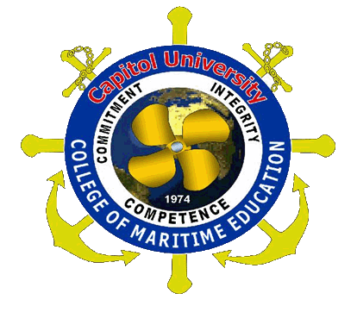
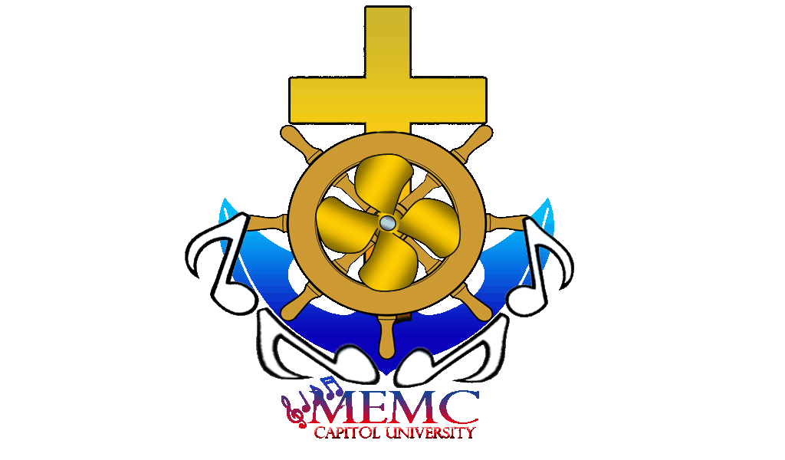
Capitol University

College of Maritime Education
Maritime Education Melodic Circle

LIST OF OFFICERS

PRESIDENT: CDT.AUX.CAPT. MELCHOR LIBRES

V-PRES:
INTERNAL: CDT.AUX.C/M RO CYRILL DENUYO
EXTERNAL: CDT.AUX.C/M HERODE LAWAS

SECRETARY: CDT.AUX.2/M NYIER SERATO
ASST. SECRETARY: CDT.AUX.2/M MARK WINZEL BANAWA

TREASURER: CDT.AUX.2/M ZOREN ECHAVES
ASST. TREASURER: CDT.AUX.2/M SERGIO BALBUENA

AUDITOR: CDT.AUX.2/M GENIE DAVE ABONG
ASST. AUDITOR: CDT.AUX.2/M GLENN REYJARY ABAO

P.R.O:
CDT.AUX.2/M GENO ALBERT MAGSINO
CDT.AUX.2/M ALAJID
CDTTE.AUX.3/M FATIMA AMANTE

Capitol University

College of Maritime Education
Maritime Education Melodic Circle

SUMMARY OF THE ACTIVITIES

MAJOR EVENTS | MINOR EVENTS
Boto mo I-Patrol Mo | Quartering
Seafarer’s Day | Regular Meeting
International Maritime Week Celebration | Regular Practice
University Intramurals | Special Meeting
Welcome assembly | Battalion Formation
Bulletin Board
First Friday Mass
Holy Spirit Mass
Time Management Seminars
STI Seminars
Mangrove Planting
Coastal Clean-up
CCB Fellowship
Orientation
Pilgrimage
Mary’s Birthday
Symposium
Dry Dock Visit
Port Visit
General Assembly

Capitol University

College of Maritime Education
Maritime Education Melodic Circle

PROBLEMS ENCOUNTERED AND SOLUTIONS

PROBLEMS ENCOUNTERED | SOLUTIONS
- Financial Problems | -We voluntarily gave financial contribution, donated foods for snacks, and any necessities to make the organization run all its tasks.
- Discipline | -We gave corresponding order to those who committed an offense which is not tolerable
- First Friday Mass Performances | -We conducted a series of rehearsal prior to the day of performance
- Attendance | -We gave order to those who failed to attend in any call of meeting by the president
- Time conflict | -We set a time for practices and meetings which will not interfere the academic schedule of the members
- Conflicts among the members | -We conduct an open forum and make an immediate talk between the concern members and settle it down
- Trainer | -The President
- Lack of Instruments | -We merged the band and the core group due to the fact that we are lack of instruments which is one of the most important things that the band must have.
- Academic Problem | -We conducted a quartering every Friday where we include lecture to discuss the current lessons from the 1styear up to 3rd year as a review for each individuals which can help them in their academic affairs.
- Inconsiderate Teachers | -We informed the instructors concern about the importance of the activities and the role of the MEMC on that activity which is beneficial both the students and even the whole college.

Capitol University

College of Maritime Education
Maritime Education Melodic Circle

SEMINARS CONDUCTED

TYPE OF SEMINARS | DATE APPROVED BY THE DSAS | VENUE | PERSONS INVOLVED
Time Management Seminar | July 23, 2011 | CU GYM | CMESBO, JUMARS, RCO, NS, MEMC, CME Cadets
Health Awareness Seminar | August 13, 2011 | MOCK Bridge | CMESBO, JUMARS, RCO, NS, MEMC, CME 2nd Year Cadets

Capitol University

College of Maritime Education
Maritime Education Melodic Circle

GENERAL ASSEMBLY

The day before the program, the president gave each one of us a task on what to do during General Assembly. Other members that were not on the meeting were sent a message for them to know what will be our flow during the program. At the day of the said program, as agreed, at exactly 0700H almost all of us were there already at the Campus Ministry. As the program started, the president managed us well to control the crowd especially our college on arranging them well, minimizing the risk of unnecessary noises. After the program was finished, again we did the same procedure to have a smooth exit and in helping to fix the chairs.

Capitol University

College of Maritime Education
Maritime Education Melodic Circle

COMMUNITY ENVIRONMENTAL PROGRAM

Last September 10, 2011 we have our community extension at Lapasan, Cagayan de Oro City. We had our assembly first in the CU Quadrangle, wherein all the officers of all organization were requested to join. There we walked from C.U. to our destination; it was fun and it served as a warm-up for us, to be ready for our community extension. We had prepared our things that were needed, such as sacks, sticks & etc. There were few instructors who joined to assist us on our cleaning operation. We had 2/M Suganob, Dr. Miñoza, 2/M Tolentino, and C/M Chin. As we started our cleaning operation, all of us cooperated well, having our pictorials for our documentations. The barangay community was thankful that we were able to reduce their garbage problem.

Capitol University

College of Maritime Education
Maritime Education Melodic Circle

INTRODUCTION

The College of Maritime Education Melodic Circle (CME-MEMC) is very much proud to the successes we had in the past few month’s activities where we have been a part of the history of the entire progress of the college and contributed for the improvement of the university. Its endeavors to impart via academic and molding the talents of the members were fully achieved through the effort of every individual who are used to become “RESPONSIBLE” and well rounded Capitolians.

As we advocate to developing the youth into a “Total Person”, we look forward in giving them a sufficient training to their emotional, mental, social, moral and spiritual life to become a catalyst of transformation. The group is not only serving a stepping stone to win themselves, but also serving them a training ground to live professional life.

For these cause, we, the CME-MEMC undergone activities relevant to the objectives that we aspired to meet. We accept opportunities wherein we could learned, trained and rounded.

As one community, CME-MEMC lived Capitol University to the fullest, as a center of education, and perfect training ground for development.

Capitol University

College of Maritime Education
Maritime Education Melodic Circle

The College of Maritime Education actively participated in all activities conducted by the university. As part of which, we the College of Maritime Education Recognized Campus Organization (CME-RCO) facilitated all the activities to help our department run all the events smoothly.
Below are some of the activities conducted by the college:

GENERAL ASSEMBLY

The College of Maritime Education Melodic Circle together with the rest of the CME-RCOs joined hands together in facilitating the welcome assembly that was conducted last July. We, as the music ministry of the college took care for the cheering. We took several times to let the cadets memorize all yells. We rehearsed it at about three consecutive nights from 7:00pm to 9:00pm.

All our efforts are paid. We did it. Although there are some who cannot execute it well but in general, we really reached the top. The cheering was so good. In fact, many personnel appreciated us and we received many best compliments not only from our dean but also from the superintendent and some other colleges.

That was one of the most overwhelming achievement we ever had.
Capitol University

College of Maritime Education
Maritime Education Melodic Circle

FIRST YEAR TO THIRD YEAR ORIENTATION

Through the effort of the College Superintendent, we were able to conduct an orientation to all year levels of our college in both departments. MEMC together with the other CME-RCOs indeed extended our hands to make this particular event successful. We did not hesitate to overtime just to facilitate the program. Thus, even our Superintendent gave his efforts and time to make the said event successful.
On this activity, the student acquired an awareness of the school policies, college policies, rules and regulations, code of conduct of CME, duties and responsibilities and many more governing their freedom and rights. All the questions being raised by the parents and students were answered personally by the Superintendent. No doubt that we, the CME, gained the trust of the parents.
We ended up these activities with a big round of applause from our administrator.

Capitol University

College of Maritime Education
Maritime Education Melodic Circle

TIME MANAGEMENT SEMINAR

This seminar is relevant to the field we took. Thus, this topic gave us an idea on how to manage our time by setting our goal ahead and set priorities.
The main objective of this seminar is to help our students attain all their plans through time management. Thus, time management is one of the problems of every individual. The speaker, Capt. James Michael A. Lumontod pointed out all the strategies on how to become successful. He added that setting priorities help students decide to the following questions: “what do I need to do?”, “how should I do it?”, “when shall it be done?”, “to whom shall it be done?”, and “why shall I do it?”.
At the end of the seminar, the students were able to classify what is the difference between necessities and wants and also the major and minor events. By doing this, they can now identify the things that they are going to prioritized.
This activity ended successfully.

Capitol University

College of Maritime Education
Maritime Education Melodic Circle

COASTAL CLEAN-UP

The College of Maritime Education Melodic Circle together with the other CME-RCO officers conducted a coastal clean-up as part of celebrating the International Maritime Week Celebration. This activity was held at Brgy. Lapasan last Sept.24, 2011. Together with us are some other government sectors.
We started the clean-up program at exactly 0630H and ended it at exactly 1130H. We were able to collect lots of waste from the coast.

FILIPINO SEAFARER’S DAY

The College of Maritime Education Melodic Circle together with the CME SBO and RCOs contributed some of our time and present ourselves to celebrate the National Filipino Seafarers Day that was held at Macabalan Port last August. This celebration was headed by Maritime Industry Authority (MARINA) and was participated by government sectors, private Institutions and Organizations.
The activity started through Motorcade around city and was followed by a mass at the port of Macabalan. The floral offering then followed, budol fights and lastly the sounding of the ship’s Morse.
The activity was very successful.

Capitol University

College of Maritime Education
Maritime Education Melodic Circle

MANGROVE PLANTING

As part of celebrating the International Maritime Week Celebration, Capitol University College of Maritime Education participated in various activities, one of which is the mangrove planting at Taytay, El Salvador.
This activity was just a continuation of the celebration were all the persons involves from the very beginning of the celebration still participating in this particular activity.
We started the mangrove planting at exactly 0600H and ended it at 0930H. The preparation was so hectic, thus some of the officers conducted a quartering prior to the said celebration.
After three hours and thirty minutes of planting, we went back to school immediately to facilitate some more activities that required our presence.
We left the coast with new planted mangroves, which means another activity was just successfully done.

Capitol University

College of Maritime Education
Maritime Education Melodic Circle

REHEARSALS

This activity is already a tradition of all music ministers. In this particular activity, the president taught the members to read notes and even basic piano playing. This is to let them explore the world of music. Also, this activity helps assess the members on their performances. Thus, through this, they can able to acquire self-awareness when it comes to music.
Our regular rehearsal will be conducted every Tuesday and Thursday of the week. Sometimes we also included other time to master the songs. Oftentimes, we conducted a series of activities if there will be an upcoming activity such as seminars, orientations, symposia, mass and any activity which is related to our field as MEMC.
These activities were successfully conducted. In fact, the members were able to develop themselves and improve the way they handle music. So far, the result of conducting this activity is really good.

Capitol University

College of Maritime Education
Maritime Education Melodic Circle

INTRAMURALS

The first day of the event (CU intramurals) was started with a parade and with a cheer. Afterwards, we, the MEMC sung the Philippine National Anthem and the CU Hymn in front of all the students of Capitol University. It was successfully done. After that, all kinds of competitive sports were opened.
We, the MEMC joined the committees to serve the food for the CME Players. During that day, we had so many responsibilities like serving the CME Players.
During the Dance sport competition, we, the MEMC and the CME students cheered our representatives. Their dances were quite good although they were not able to qualify and reach the final.
Overall, the activities were so successful.

Capitol University

College of Maritime Education
Maritime Education Melodic Circle

BAYAN MO, I-PATROL MO

Capitol University was honored to have the BMPM last June that was spearheaded by the ABS-CBN. This was conducted for the whole nation to be aware about their responsibilities towards the society. Thus, by having this campaign, more and more of our countrymen were known about it already.
CU-CME, as one of the biggest college of this university, was tasked to be the main audience. That means, being one of the CME-RCO, we had a vital role to play during that day.
We, the CME-RCO officers led all the cadets to be here. Prior to that activity, we conducted a special quartering to make our response earlier.
MEMC, as a spiritual organization, recited the Holy Rosary to open the program. We did it at exactly 0400H. After the rosary, we proceeded to the gymnatorium for the orientation. We were the first audience of the said program. But actually, we participate on it until its last minute.
We successfully run our part and indeed received very warmth congratulation from the superintendent of the college, Capt. Emiliano E. Duran, MM, MBM.
All in all, we did another big accomplishment.

Capitol University

College of Maritime Education
Maritime Education Melodic Circle

BULLETIN BOARD RESTRUCTURING

Every month we always conduct a special quartering for our bulletin board. We used to suit the design of our bulletin board to be related in every month’s theme or celebration. As we all know that every theme we used to reconstruct our bulletin board to be fitted out and every celebration theme that we have is graded by the Department of Student Affair and Services (DSAS).

Capitol University

College of Maritime Education
Maritime Education Melodic Circle

FIRST FRIDAY MASS

Capitol University makes a habit that every first Friday of the month we have our mass. We used to be the in-charge of the choral singing and altar serving. Not all the students can attend every first Friday mass because some have their classes depending on their vacant time in morning sessions.
Due to time conflicts, we sometimes encountered a problem regarding our performances because not all of can really attend our regular practices and even the final performance itself because some instructors are not considerable.
However, we never get down. We keep serving because we know that by doing this; we can appreciate what life means. Despite of all this things, we have made it to the top. Everything was still manageable.

Capitol University

College of Maritime Education
Maritime Education Melodic Circle

OPERATION LINIS

Operation linis was conducted for us to clean our department, to maintain its cleanliness, to be presentable for those visitors who visited our department and to have good feedback from them.
On the other hand, cleaning our department is not just to show people that we the maritime students are just complying our responsibilities to cleans our department, it is also to train students, because onboard a vessel, this is a practice that a cadet must have.

Capitol University

College of Maritime Education
Maritime Education Melodic Circle

DRY DOCK VISIT

All students are required to visit at Jasaan for dry dock. We travelled from Capitol University to our destination for about an hour. Upon arrival, we went to a particular place where the vessel are being constructed and renovated. The students were divided to groups so that we will not so crowded, there we have our tour guide to show us what are they doing and what are those equipments to use to construct a vessel. We have also picture taking for our documentations. After we done visiting, we took our snacks and preparing to go back to our school at C.D.O.
The visit was so fun and gave us more knowledge and experience for that particular visit.

Capitol University

College of Maritime Education
Maritime Education Melodic Circle

1ST REGULAR MEETING
July 11, 2011
VENUE: CAMPUS MINISTRY
TIME: 6:00PM-8:00PM
Attendance:
Refer to the attendance checked by the president
Declaration of Quorum:
The secretary announced the quorum
Opening Prayer
Agenda:
- Final MEMC members
- Subject code
- Obligation
- Monthly dues
- Registration
- Type b uniform

Meeting proper

Minutes:
- The president confirms the total population of the MEMC members who are officially registered as MEMC for the first semester of 2011-2012. Base on the official list, 60 members was officially listed.

- The president asked the subject code of the members to give them an incentive as stated in constitution and our by-laws.
- The president reminds the groups with regards to the obligation of the members as being agreed by the group. it includes the following:
  - Registration fee of p100.00 of each member for the entire 3 academic years.
    - Whereas, this will serve as funds for MEMC since the group has limited members only
    - Whereas, it will used for group expenses such as office supplies, bulletin boards restructuring, snacks during operation linis and other expenses where contribution is necessary.
  - Semestral due
    - whereas, it will also serve as an additional funds for the MEMC to help the organization works better and sustain all the needs
  - Blue clear book.
    - Whereas, this will serve as an output for all the memc members.
    - Whereas, the organization will not hold this but the owner itself. This will serve as their compilation and will be checked every term.
  - type b uniform
    - whereas, this will serve as an extra uniform for the group
    - whereas, it will be worn during Tuesday and instead of wearing of departamental type b for the memc to be recognized
    - whereas, it will be used during outside school activities such as port and ship visits, dry dock visits and any outstretch activities such as tree planting and community extension.
Since no more issues left undiscussed; no more suggestions arouse from the members, no more violent reaction, the president moved to close the meeting and was seconded by the group.
Closing prayer was recited and meeting was adjourned.
I hereby certify and witness to the correctness of the abovementioned minutes that all the information above is right.

Prepared by:

CDT.AUX.2/M NYIER SERATO
SECRETARY, MEMC

Concurred by:

CDT.CAPT.MELCHOR LIBRES
PRESIDENT, MEMC

