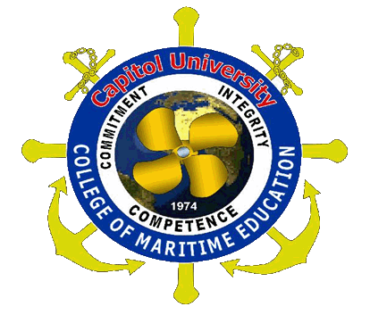
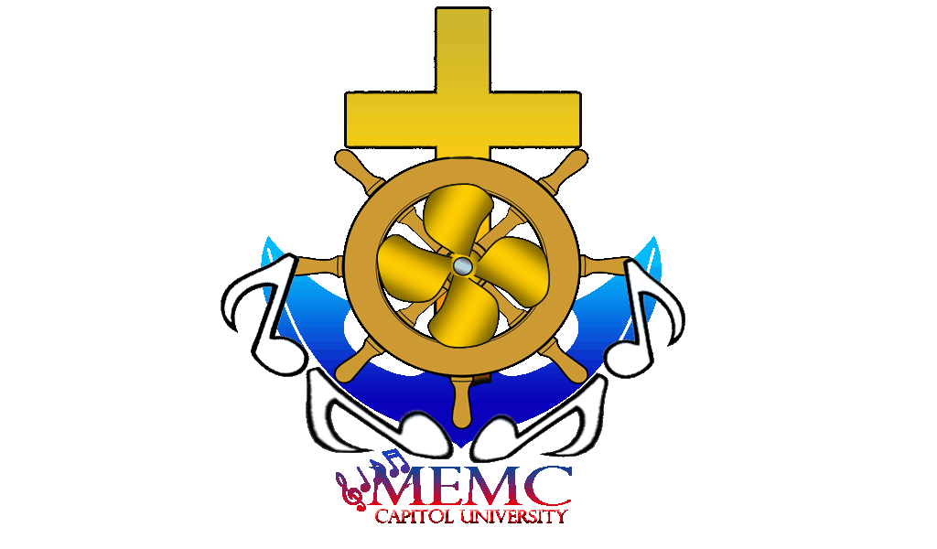
Capitol University

College of Maritime Education
Maritime Education Melodic Circle

Financial Statement
1ST semester S.Y. 2011-2012

Allocation from the Previous Administration P 1,259.00
Time Management Seminar 1,046.00
STD Seminar 600.00
Dry Dock Visit 694.27

P 3,599.27
Less: Disbursement

20 June 2011 Snacks 411.00
22 June 2011 Color Printing 30.00
24 June 2011 Snacks 293.00
25 June 2011 Snacks 149.00
25 June 2011 Snacks 110.00
30 June 2011 Snacks 150.00
07 July 2011 Snacks 702.00
12 July 2011 Office Supplies 98.00
12 July 2011 Photocopy 64.00
13 July 2011 Photocopy 14.00
20 July 2011 Printing 24.00
22 July 2011 Snacks 198.00
22 July 2011 Office Supplies 669.00
25 July 2011 Printing (songs) 46.00
25 July 2011 Printing 40.00
26 July 2011 Snacks 114.00
26 July 2011 Photocopy 5.00
29 July 2011 Snacks 217.00
29 July 2011 Snacks 249.00
P 3,583.00

Cash on Hand P 16.27

Prepared By: Certified Correct :
Cdt. Aux 2/m Echavez,Zoren C. Cdt. Aux 2/m Abong, Genie Dave P.
Treasurer, MEMC Auditor, MEMC

Approved by: Attested by:
Cdt.Aux Capt. Melchor, Libres H. Dr. Romeo B. Minoza

Capt. Emiliano E. Duran, MM
Superintendent, College of Maritime Education

