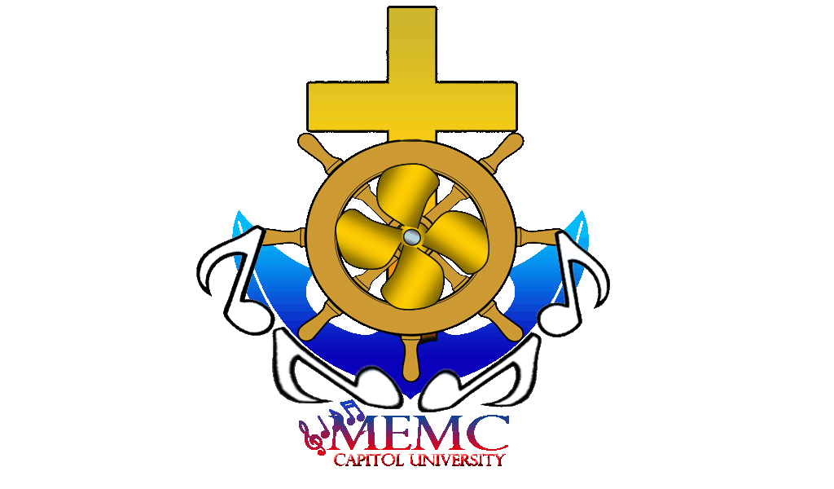
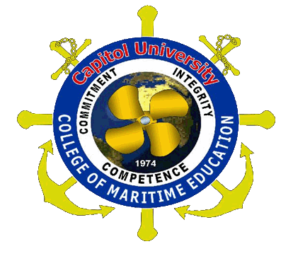
Capitol University

College of Maritime Education
MARITIME EDUCATION MELODIC CIRCLE
Cagayan de Oro, Philippines

To : SIR LEO PANGAN
Head, VPFMO

Thru : DR.ROMEO B. MIÑOZA JR.
Assistant to the Superintendent

Dear Sir :

Praise be Jesus and Mary!

This is in relation to the incident that happened October 7, 2011 wherein 7 of the MEMC members accommodate the MOCK BRIDGE during the quartering without the permission from your office.

We would like to apologize for what had happened. We admit that it is really a big mistake for us. We supposed to accommodate any vacant room which is the only accommodation allowed for us every quartering. However, we decided to stay at MOCK BRIDGE at around 0445H in the morning.

We informed DR.MINOZA late because it is accidentally that we bring with us one casualty from RCO-Aspirant. I have the key because I was not able to return it to DR.MINOZA a week prior to that day after turning off all the lights.

In this reason, I humbly ask sorry with you and hoping that you could consider my approach. I promise not to do it again. This will be the first and the last offense that I could make.

Thank you for your consideration and May God bless us all.

We are looking forward for your most favorable response.

Thank you and May God Bless us all!

Very respectfully yours,

CDT.CAPT.MELCHOR LIBRES
President, CU-CME-MEMC

