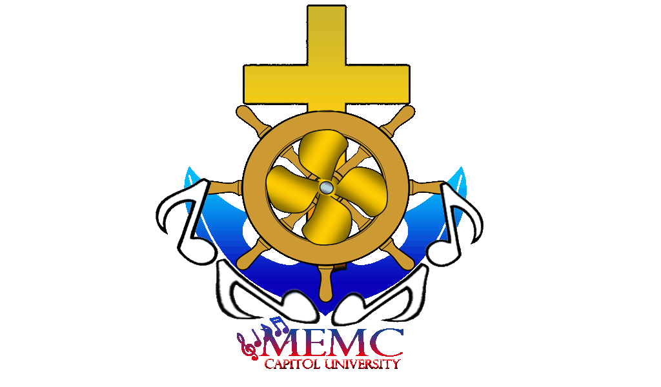
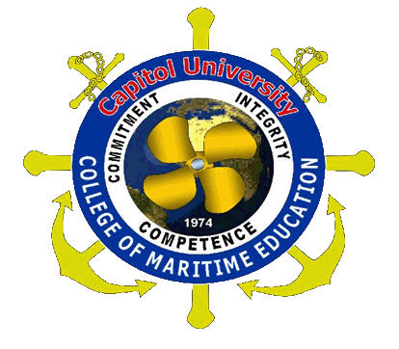
Capitol University
College of Maritime Education
MARITIME EDUCATION MELODIC CIRCLE
Cagayan de Oro City
Philippines 9000

CALENDAR OF ACTIVITIES

JUNE
DATE | ACTIVITIES | PERSONS INVOLVED | VENUE | STATUS  Achieved/Not Achieved
01-10 | OPLAN ASSIST “ENROLMENT ASSISTANCE” | CMESBO,RCO,NS,MEMC,JUMARS | CME Academic Building
13 | REGULAR MEETING | CMESBO,RCO, MEMC,JUMARS, & NS | CMESBO Office
17 | Bayan Mo i-Patrol Mo | CME SUPRINTENDENT, CMESBO,RCO, MEMC,JUMARS, & NS | Capitol University
18 | OPERATION LINIS | CMESBO, JUMARS, RCO, NS, MEMC  First year and Second year cadets | CME Academic Building
June 20 to July 08 | RCO,NS& MEMC RECRUITMENT | RCO, MEMC AND CME CADETS | RCO,NS & MEMC  Offices
24 | REGULAR MEETING | CMESBO,RCO, MEMC,JUMARS, & NS | CMESBO Office
25 | Filipino Seafarers Day | CME Superintendent, CME Instructors, CMESBO,RCO, MEMC,JUMARS, & NS | Philippine Port Authority  Macabalan CDOC
25 | First Year General Orientation with parents | CME SUPRINTENDENT,STO CMESBO,RCO, MEMC,JUMARS, & NS | MULTI-PURPOSE HALL
30 | Charter Change Seminar | CSG Officers, CU Students and Guest Speakers | Conference Hall
JULY
1 | FIRST FRIDAY MASS | All CU Community | Gymnasium
02 | Dry Dock | CME SUPRINTENDENT,STO CMESBO,RCO, MEMC,JUMARS, & NS | Jasaan,Misamis,Oriental
02 | First Year General Orientation with Parents | CME SUPRINTENDENT,STO CMESBO,RCO, MEMC,JUMARS, & NS | MULTI-PURPOSE HALL
04 | REGULAR MEETING | CMESBO,RCO, MEMC,JUMARS, & NS | CMESBO Office
8 | Welcome Assembly | CSG,CME Officers and CU Students | GYM
09 | First year & Second Year General Orientation with Parents | CME SUPRINTENDENT,STO CMESBO,RCO, MEMC,JUMARS, & NS | MULTI-PURPOSE HALL
16-20 | Prelim Examination | C.U Students | Capitol University
23 | TIME MANAGEMENT SEMINAR  Afternoon- 1st year cadets. | CMESBO,RCO, MEMC,JUMARS, NS,FRESHMEN & TRANSFEREES | MULTI-PURPOSE HALL
23 | Third Year General Orientation with Parents | CME SUPRINTENDENT,STO CMESBO,RCO, MEMC,JUMARS, & NS | MULTI-PURPOSE HALL
22 | REGULAR MEETING | CMESBO,RCO, MEMC,JUMARS, & NS | CMESBO office
30 | Dry Dock Visit/ Ship & port Visit | CMESBO, RCO, MEMC, JUMARS, NS & CME CADETS.
30 | OPERATION  LINIS | CMESBO, JUMARS, RCO, NS, MEMC  CME Cdts. | CME Academic Building
AUGUST
5 | FIRST FRIDAY MASS | All CU Community | Gymnasium
6 | COASTAL CLEAN-UP | CME Community Extension Officer, CME Superintendent,  CMESBO, JUMARS, RCO, NS, MEMC, CME cadets.
12 | REGULAR MEETING | CMESBO,RCO, MEMC,JUMARS, & NS | CMESBO office
13 | HEALTH AWARENESS SEMINAR | CMESBO,RCO, MEMC,JUMARS, NS AND CME CADETS | MULTI-PURPOSE HALL
20 | OPERATION  LINIS | CMESBO, JUMARS, RCO, NS, MEMC  First year and Second year cadets | CME Academic Building
20 | Dry Dock Visit/ Ship & port Visit | CMESBO, RCO, MEMC, JUMARS, NS & CME CADETS.
26 | REGULAR MEETING | CMESBO,RCO, MEMC,JUMARS, & NS | CMESBO office
27 | TREE PLANTING | CMESBO,RCO, MEMC,JUMARS, NS AND CME CADETS | MALASAG CDO
SEPTEMBER
DATE | ACTIVITIES | PERSONS INVOLVED | VENUE | STATUS  Achieved/Not Achieved
2 | FIRST FRIDAY MASS | All CU Community | Gymnasium
3 | Midterm Examination | C.U Students | Capitol University
9 | REGULAR MEETING | CMESBO,RCO, MEMC,JUMARS, & NS | CMESBO office
10 | PERSONAL HYGIENE SEMINAR | CMESBO, JUMARS, RCO, NS, MEMC, CME cadets
10 | FELLOWSHIP | CAMPUS MINISTRY, ALL CHRISTIANS RELIGIOUS ORGANIZATION | MOGCHS
17 | ENHANCING SPIRITUAL AWARENESS SEMINAR | CMESBO, JUMARS, RCO, NS, MEMC  3rd YR CME cadets | MULTI-PURPOSE
17 | OPERATION  LINIS | CMESBO, JUMARS, RCO, NS, MEMC  First year and Second year cadets | CME Academic Building
17 | DRUG ABUSE AND PREVENTING SEMINAR | SUPERINTENDENTCME-SBO, MEMC, NS, RCO, JUMARS, CME CADETS | MULTI-PURPOSE
23 | REGULAR MEETING | CMESBO,RCO, MEMC,JUMARS, & NS | CMESBO office
24 | PORT & SHIP VISIT / DRY DOCK | CME Community Extension Officer, CME Superintendent,  CMESBO, JUMARS, RCO, NS, MEMC, CME cadets  .
 | INTERNATIONAL MARITIME WEEK CELEBRATION | Superintendent, CMESBO, RCO, JUMARS, NS, MEMC, all cadets of the CME students of Capitol University | MARITIME BUILDING
10-11 | UNIVERSITY  INTRAMURALS | C.U Administration, CME Superintendent, CME Faculty CMESBO, RCO, JUMARS, NS, MEMC,  All cadets of the CU-CME.
OCTOBER
7 | FIRST FRIDAY MASS | All CU Community | Gymnasium
12-15 | Final Examination | C.U Students | Capitol University
15 | OPERATION  LINIS | CMESBO, JUMARS, RCO, NS, MEMC  First year and Second year cadets | CME Academic Building

OTHER ACTIVITIES:
- MEMC REHEARSALS TO BE CONDUCTED EVERY TUESDAY AND THURSDAY.
- MEMC REGULAR MEETING WILL BE CONDUCTED EVERY 1ST AND 3RD FRIDAY OF THE MONTH.
- DAILY ROSARY WILL BE DONE EVERYDAY AT EXACTLY 1130H.

Prepared by: Concurred by:

CDT.AUX.2/M NYIER SERATO CDT.AUX.CAPT.MELCHOR H. LIBRES
Secretary, MEMC President, MEMC

Noted by:

2/M JOSE JONALD Y. ECHEVERIA 3/E RONALDO PALILAN SR.TERESITA G. BALBERAN, CM
Adviser, MEMC Adviser, MEMC Directress, Campus Ministry

Recommending Approval:

CAPT. EMILIANO E. DURAN, M.M, M.B.M
Superintendent, College of Maritime Education

