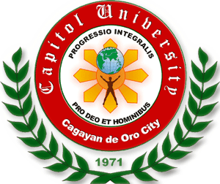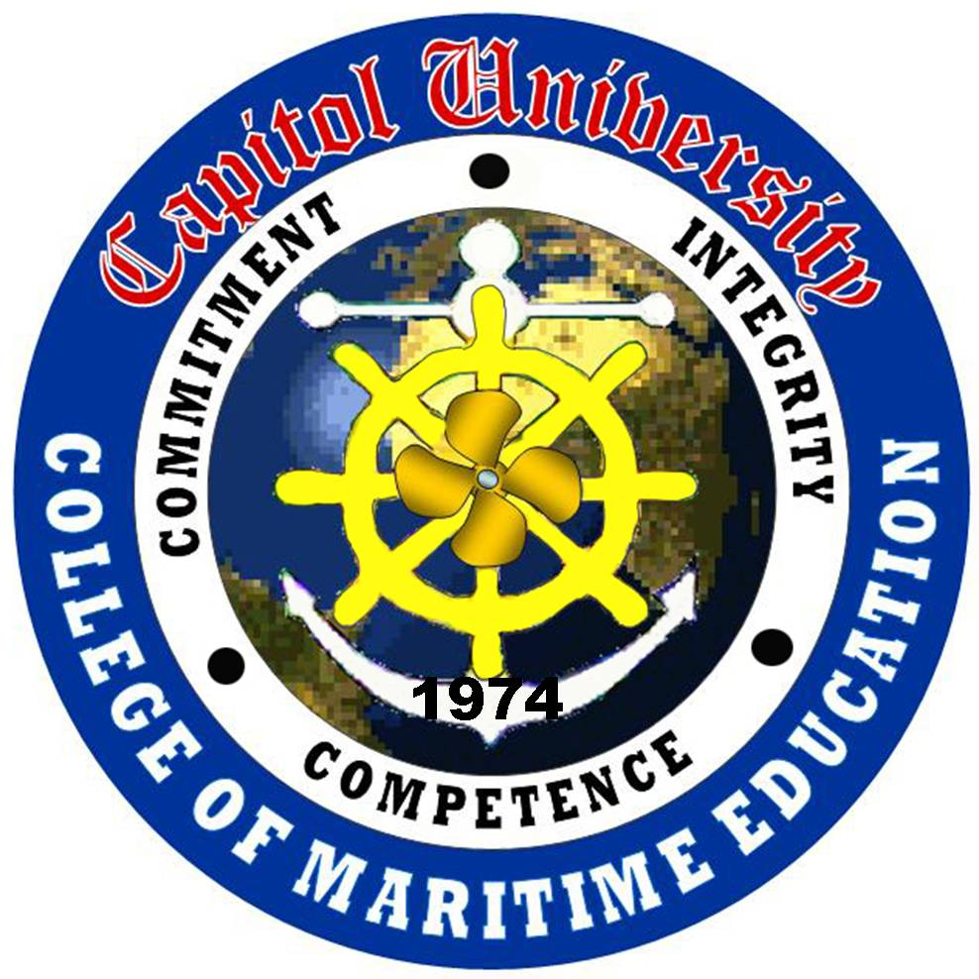Capitol University

Cagayan de Oro City
College of Maritime Education

Maritime Education Melodic Circle
December 7, 2010

DR. VINCENT S. SALAS
Vice-President for Operation, Planning and Development
This University

Thru: MR. LEO PANGAN
PPFMO

Dear Sir:

Peace in Christ!

The Maritime Education Melodic Circle (MEMC) will conduct a seminar-workshop on “Research Data Gathering”. The objective of this seminar-workshop is to equip the maritime students on how to gather information through research-based methods. Please be informed that the second year maritime students have presented research proposal last first semester SY 2010-2011. The said activity would be of great magnitude to the students to come up with a quality research.

The seminar-workshop will be scheduled on Saturday, December 4, 2010 from 08:00 am to 11:00 am for the second year level, and on January 8, 2011 for the first year level at the same time.

With this endeavor, we would like to ask permission to use the CU Multi-Purpose Hall in the above-mentioned time.

We are hoping for your favorable response.

Thank you.

Respectfully yours,

CDTTE. AUX. CAPT. KISSARNE N. JANOYOG
President, MEMC

Attested by:

DR. ROMEO B. MIÑOZA
Adviser, MEMC

Recommending Approval:

CAPT. JAMES MICHAEL A. LUMONTOD, MPSM, MBM
Dean, Marine Transportation Department
College of Maritime Education

